**Energov Refresh**

NOTE: This Utility should be run from the desktop of the EnerGov application server as an admin on both that server AND in SQL

Run the SQL EnerGov On-Demand backup for EnerGov **BEFORE** refreshing to get what is currently in the EnerGov environment into the environment being refreshed

**NOTE: ALWAYS** make sure you have a good backup **BEFORE** performing a refresh

1. Select the number corresponding to the EnerGov environment to be refreshed from (source):

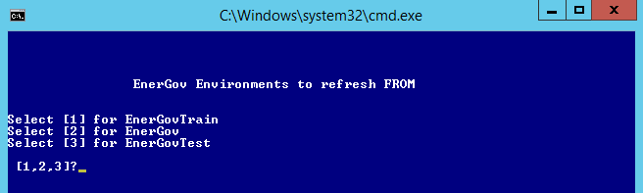

1. Select the number corresponding to the EnerGov environment to be refreshed (target):

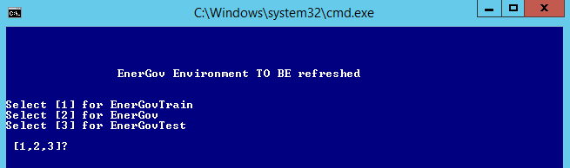

1. Warning will display that the “target” EnerGov database is about to be overwritten (in this case, “energovtest” will be refreshed) :

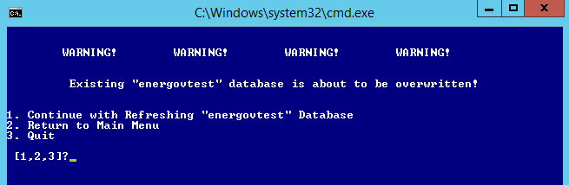

1. Select “1” to continue

**NOTE:** if “EnerGov” is selected as the target, the refresh will not continue as it is considered the “Live” EnerGov database